**WEEK 9**

**AIM:** To write a Java program that creates a user interface to perform integer divisions.

**THEORY:** Applets are small applications that are accessed on an Internet server, transported over the Internet, automatically installed, and run as part of a Web document. After an applet arrives on the client, it has limited access to resources, so that it can produce an arbitrary multimedia user interface and run complex computations without introducing the risk of viruses or breaching data integrity. The Applet class is contained in the java.applet package. All applets are subclasses of Applet. Thus, all applets must import java.applet

**ALGORITHM:**

STEP1: START

STEP2: Create an applet using extends Applet class.

STEP3: Create three text fields to accept Num1, Num2 and Result field.

STEP4: Create two buttons named “Divide” to generate result and “Clear” to clear the three text fields.

STEP5: Use JoptionPane class to create message dialog box.

STEP6: Use actionPerformed() method of ActionListener interface to handle button events.

START7: END

**SOURCE CODE:**

import java.applet.*;

import java.awt.*;

import java.awt.event.*;

import javax.swing.*;

/*<applet code=Div width=500 height=500>

</applet>*/

public class Div extends Applet implements ActionListener

{

Button b1,b2;

Label l1,l2,l3;

TextField tf1,tf2,tf3;

public void init()

{

b1=new Button("COMPUTE");

b1.addActionListener(this);

b2=new Button("CLEAR");

b2.addActionListener(this);

tf1=new TextField(20);

tf2=new TextField(20);

tf3=new TextField(20);

l1=new Label("NUMBER1");

l2=new Label("NUMBER2");

l3=new Label("RESULT");

add(l1);

add(tf1);

add(l2);

add(tf2);

add(l3);

add(tf3);

add(b1);

add(b2);

}

public void actionPerformed(ActionEvent ae)

{

if(ae.getSource()==b1)

{

try

{

int a=Integer.parseInt(tf1.getText());

int b=Integer.parseInt(tf2.getText());

int c=a/b;

tf3.setText(""+c);

}

catch(NumberFormatException ex)

{

tf3.setText(" ");

JFrame f=new JFrame();

JOptionPane.showMessageDialog(f,"Enter only numbers");

}

catch(ArithmeticException ex)

{

tf3.setText(" ");

JFrame f=new JFrame();

JOptionPane.showMessageDialog(f,"Enter second value non zero");

}

}

else

{

tf1.setText("");

tf2.setText("");

tf3.setText("");

}

}

}**OUTPUT:**

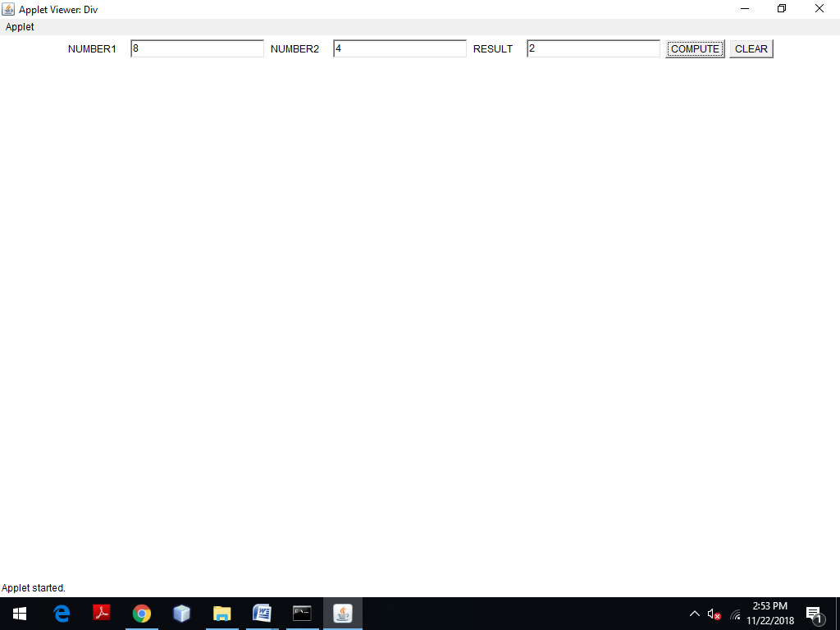

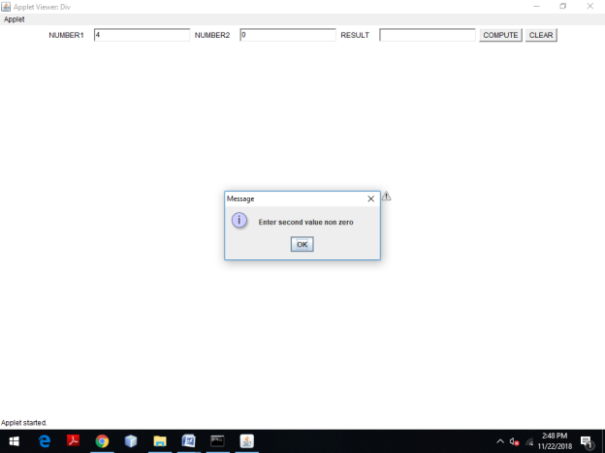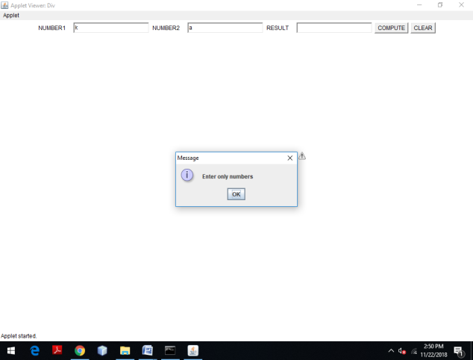

**VIVA - VOCE:**

1. What is the purpose of ArithmeticException?

An arithmetic exception in java is a Runtime exception present in the java. lang package. JVM throws Arithmetic Exception when a wrong mathematical expression occurs in a java program.

1. What is the purpose of NumberFormatException?

The NumberFormatException occurs when an attempt is made to convert a string with improper format into a numeric value. That means, when it is not possible to convert a string in any numeric type (float, int, etc), this exception is thrown.

1. What is the use of JOptionPane?

JOptionPane is generally used to access the standard dialog boxes like confirm dialog box, message dialog box, and input dialog box. These dialog windows are used to present information to the user or to solicit input from them.

1. What is dialog box?

Dialog boxes are graphical components that are usually used to display errors or give some other information to the user. They are part of the three top-level containers that each Java graphical user interface (GUI) application must have as a root. Dialogs are created as part of a frame.

1. What is the use of ActionListener?

Java ActionListener is an interface in java. awt. event package. It is an type of class in Java that receives a notification whenever any action is performed in the application.